*Unlimited IV EDUBOT*

*Technical Document*

Document Number : 1

Document Revision : 1

Date : November 2021

# **TABLE OF CONTENTS**

TABLE OF CONTENTS

INTRODUCTION

1.1 SYSTEM OVERVIEW

1.2 PURPOSE

1.3 SCOPE

DESIGN CONSIDERATIONS

2.1 REUSABILITY OF COMPONENTS

2.2 USE OF STANDARDS

2.3 ASSUMPTIONS AND CONSTRAINTS

SYSTEM DESIGN

3.1 CASE DESIGN

3.2 ELECTRONIC AND SOFTWARE SYSTEM

REFERENCES

APPENDIX A - TABLES AND GLOSSARY

# **INTRODUCTION**

#### **1.1 SYSTEM OVERVIEW**

The Unlimited IV educational kit is a low-cost, USB-powered or battery powered robot designed to gamify STEM based learning.

#### **1.2 PURPOSE**

The purpose of this document is to:

* Define the specifications for the robot
* Establish assumptions and constraints
* Detail the case design
* Illustrate the electronic and software systems

#### **1.3 SCOPE**

This system design document outlines the design of the Unlimited IV educational kit and establishes use case specifications including the reusability of the components, standards, assumptions, and constraints. It will also detail design considerations for the electronic and software systems. This document can be referred to for informational purposes only.

# **DESIGN CONSIDERATIONS**

#### **2.1 REUSABILITY OF COMPONENTS**

Since the central processor of the kit is a Raspberry Pi Pico which is a well documented off the shelf hobbyist piece of hardware, the user can remove the Raspberry Pi to use in another project thus creating more flexibility to reuse components. This is made all the more easier by the ease of access provided by our case design.

#### **2.2 USE OF STANDARDS**

The Unlimited IV educational kit is compliant with Universal Serial Bus (USB) industry standards. The power supply has a standard shielding/current limiting circuit to prevent current spikes from the USB burning the Raspberry Pi Pico or any of the other electric circuit components.

#### **2.3 ASSUMPTIONS AND CONSTRAINTS**

Assumptions and constraints taken into consideration in the design of the power supply include:

* the user plugs in a 500mA USB to the system, at 5V when in tethered mode
* there is no additional power into the system to power active components
* the Raspberry Pi Pico has a fairly limited number of input/output pins available to be user programmable and accessible
* the UART functionality with the virtual serial port would function as expected if additional software was installed to properly simulate it in Proteus.
* the Raspberry Pi Pico is incapable of producing analog signals with negative voltage values so this can only be implemented with complex inverter circuits outside the Raspberry Pi PIco
* the Raspberry Pi Pico’s Pulse Width Modulation capable pins are set to work at specific frequency(19.2MHz) with little to no user customization for basic users.
* when working at non-standard frequencies, the system is fairly unstable
* the electrical components in the system (especially in the signal processing and output circuits) dissipate little to no power, which is fairly unrealistic

# **SYSTEM DESIGN**

#### **3.1 CASE DESIGN**

The default design of the educational kit focuses on functionality, simplicity and efficiency. The implementation of simplicity in the design makes it recognizable for our target audience, as opposed to a complex design. With a modular design and simplistic functions, the educational kit is upgradeable, and the parts are more easily exchangeable. This minimalistic design with simplistic shapes that only include essential features allows for the case to be 3D printable. The ability to provide a more bare-boned kit helps us price the kit more aggressively making it accessible to a wider audience. The modular nature of the design allows us to incorporate an element of fun as it leaves a door for creativity open (within the guidelines provided by us). Additionally, designing a case with recyclable/reusable/sustainably sourced materials available to them could be presented as an engaging task for the students.

The base chassis of the robot is very simple. There are several mounting holes specific for the raspberry pi, the front swivel wheel, and the motor mounts. There is then a grid of holes. This grid is what we insert other components, such as sensors, into. The even constant spacing means that the user can place components anywhere on the bot, which encourages trial and error and optimal design. It also means that a more advanced user could create their own parts that easily mount to the bot.

#### **3.2 ELECTRONIC AND SOFTWARE SYSTEM**

The electronic circuit was built with considerations for the design parameters discussed earlier. The circuit design is made to be fairly simplistic by avoiding active elements that require additional power or additional logic added to the Raspberry Pi in order to function. These cuts are explained in more detail in the part selection section of this document. It should be noted that these compromises had no effect on the actual performance and functionality of the kit.

As mentioned earlier, the system was built with modularity in mind, which is why an active effort was made to try to free up as many Raspberry Input/Output pins as possible such that additional third party elements(sensors and actuators) could be added by the end-user to improve/customize the functionality of the kit. The safety of the system was also accounted for by the inclusion of a current limiting circuit that limited the current entering the Raspberry Pi to 500mA. Different passive and active implementations of this circuit were considered but ultimately opted for an active element (a standard transistor linear current limiting circuit) as opposed to a passive load (fuse in series with a purely resistive load). This was chosen because despite having a fairly robust modular system, it is expected that replacing a fuse every time the current through the USB cable delivers power to the Raspberry spikes would become a severe inconvenience. Below is a schematic for the current limiting circuit that will be implemented in our system.

**3.3 Drive Design**

The bot is driven by two rear wheels with one central, swivelling, free spinning wheel in the front. This design reduces the number of motors needed to drive the bot, while still allowing very precise movement with a very tight turning radius. Reducing the number of motors reduces cost. Having a motor on each side means that the wheels do not need to turn in order to turn the direction of the bot, rather it is done with speed control of the left and right motor.

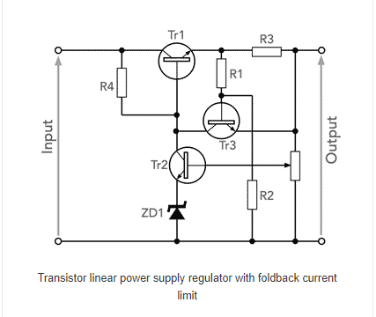

A Raspberry Pi Pico is used as the microprocessor choice for this power supply. Some concessions had to be made as a result of this restriction but the Raspberry Pi Pico is set up to be user replaceable with any alternative Raspberry Pi or even Arduino board(with appropriate instructions to be provided). Note that the Raspberry Pi Pico has 26 General Purpose Input/Output pins that are user addressable and programmable, with 3 of these being capable of being used as purely analogue inputs.

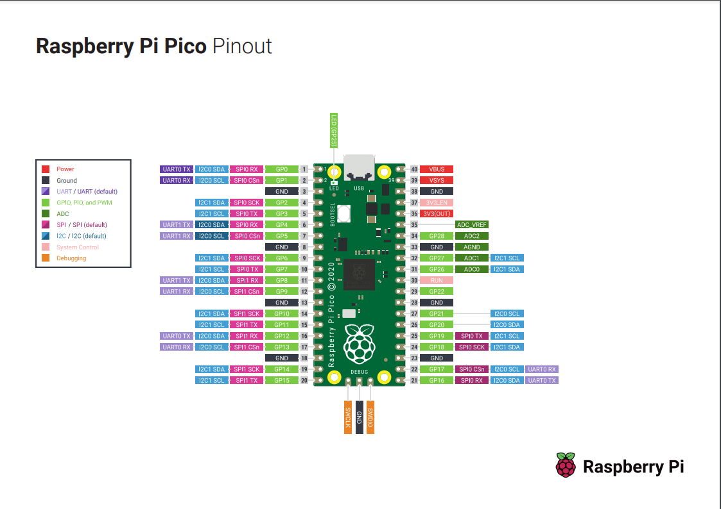

Some of these pins are also Pulse Width Modulation capable which is particularly relevant to this use case. Pulse Width Modulation is a technique that generates variable-width pulses to represent the amplitude of an analog input signal.

This technique acted as the basis for logic behind one of the lessons in our included lesson plan, the function generator for driving a motor. In the lesson, of the 26 I/O pins, six pins are connected to the two rotary switches and two flip switches which act as the output signal type selector inputs for both output channels. The input from the rotary switches is used to switch between square/DC output or triangular/sinusoidal output for each motor/actuator by choosing between the output pins and therefore signal processing circuit available to the motor/actuator that the corresponding output signal is routed to, and the flip switches are used to power a relay that switches between the different output pins. The logic behind this is implemented in the following C code in the Lesson Example Section of this document.

Outside of interfacing with sensors and actuators, the Raspberry Pi Pico has the UART(universal asynchronous receiver-transmitter) functionality which is a device-to-device communication protocol which could make it the subject for interactive command line interfacing. The base design of the kit includes a Bluetooth module that has been programmed for remote motor control via a mobile app;ication. The source code for the application is open source and will be hosted on a forum where it can be modified and shared by users for other users with similar projects.

# **REFERENCES**

“Documentation,” *RaspberryPi*. [Online]. Available: https://www.raspberrypi.com/documentation/. [Accessed: 20-Nov-2021].

CAD for the wheel

<https://grabcad.com/library/tt-motor-wheel-yellow-1>

CAD for the motor

<https://grabcad.com/library/yellow-dc-motor-1>

CAD for the caster

<https://grabcad.com/library/yellow-dc-motor-1>

# **APPENDIX A - TABLES AND GLOSSARY**

Table 1 - Cost breakdown of parts:

| **Index** | **Quantity** | **Part Number** | **Manufacturer Part Number** | **Description** | **Customer Reference** | **Available** | **Backorder** | **Unit Price** | **Extended Price CAD** |
| --- | --- | --- | --- | --- | --- | --- | --- | --- | --- |
| 1 | 1 | 2648-SC0915CT-ND | SC0915 | RASPBERRY PI PICO RP2040 BOARD |  | 1 | 0 | 5.44 | 5.44 |
| 2 | 2 | 1528-1150-ND | 711 | STANDARD MOTOR 9100 RPM 6V |  | 2 | 0 | 2.65 | 5.30 |
| 3 | 2 | 1528-2964-ND | 4205 | BLACK MULTI-HUB WHEEL FOR TT / L |  | 2 | 0 | 2.82 | 5.64 |
| 4 | 1 | 1738-1385-ND | SER0006 | SERVOMOTOR RC 4.8V |  | 1 | 0 | 4.92 | 4.92 |
| 5 | 1 | 150-BM70BLE01FC2-0B05BA-ND | BM70BLE01FC2-0B05BA | BLUETOOTH BLE MODULE NO ANTENNA |  | 1 | 0 | 9.83 | 9.83 |
| 6 | 1 | 490-4698-1-ND | PKM13EPYH4000-A0 | BUZZER PIEZO 1.5V 12.6MM TH |  | 0 | 1 | 0.46 | 0.46 |